Raspberry Pi – interactive music instrument

Welcome to the Raspberry Pi booth!

In this demo, you will perform a few simple tasks to make the device responsive to your hand gestures and play music.

1. Open the file “exercise.py”
2. Set a value for GPIO_ECHO and GPIO_TRIG (one of the GPIO pins)
3. Connect the sensor to the Raspberry Pi with the 4 connections wire:

Gnd -> Ground

Echo -> GPIO_xx (from step 2)

Trig -> GPIO_xx (from step 2)

Vcc -> 3.3v

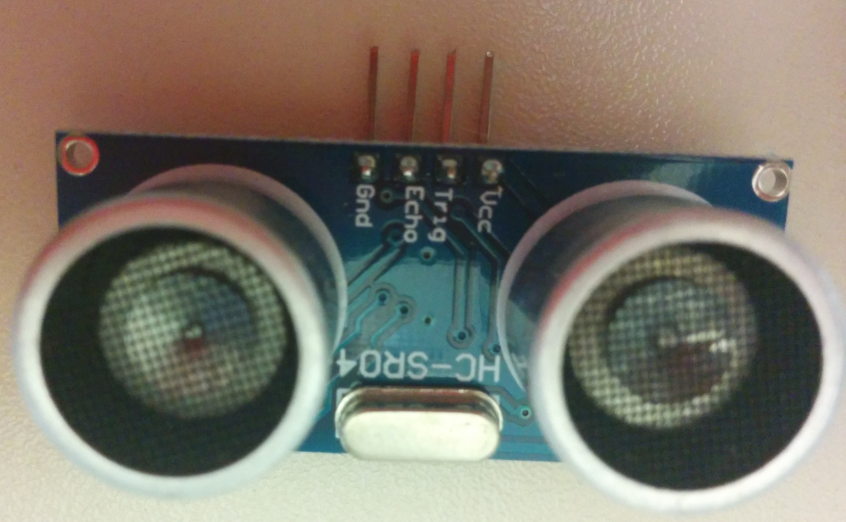

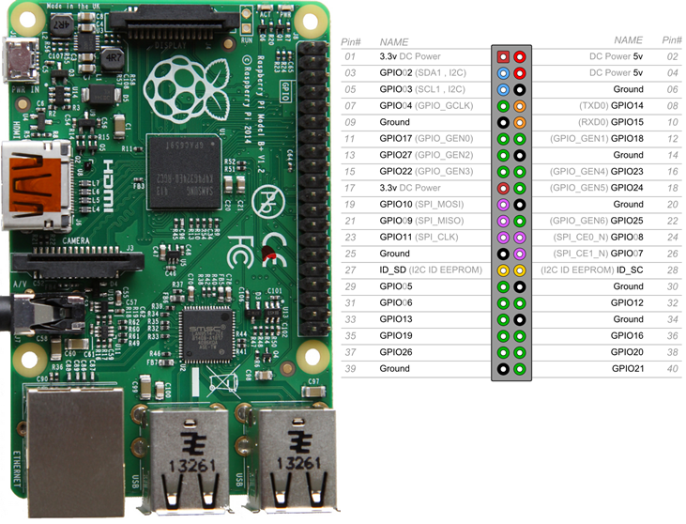

1. Get the distance by calling the func (Step 2 at the code)
2. Set the desire distance, from where it should start playing (Step 3 at the code)
3. Run the code…